Double Features – ($175/Year)

Schedule Importing - (Double)
With this feature we will import schedules you have listed on an excel file. This is a great feature if you have previously used another scheduling software and you don’t want to do double data entry. We do suggest that you use Home Campus for all of your scheduling needs because it will save you more time overall.

Score Poster – (Double)
This is a great time saving feature when you are inputting scores. This allows you to input all of your scores for a specified timeframe all on one page.

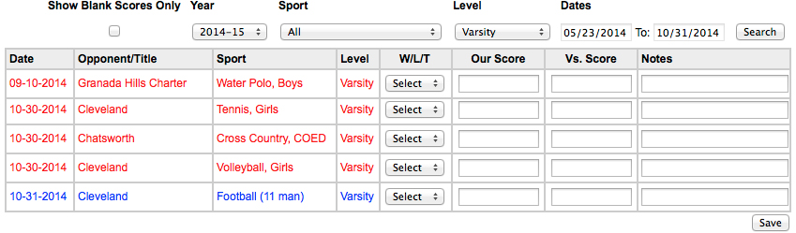

Multiple Game Templates - (Double)
Input multiple levels or multiple games all with one entry. Create templates with preset game times, locations, teams, etc. He an example of a great use of a Multiple Game Template below:

One input using the “Basketball Template” and the following is scheduled!

Date | Time | Location | Sport | Level
1/15/2015 | 7:00PM | Home | Basketball, Boys | Varsity
1/15/2015 | 5:30PM | Home | Basketball Girls | Varsity
1/15/2015 | 4:00PM | Away | Basketball, Girls | Junior Varsity
1/15/2015 | 2:30PM | Home | Basketball, Boys | Freshman
1/15/2015 | 3:00PM | Away | Basketball, Boys | Junior Varsity
1/15/2015 | 5:00PM | Away | Basketball, Girls | Freshman

Triple Features – ($350/Year)

Facilities – (Triple)
Add all of your on campus facilities to the system and tag them when they are being used. Whenever you try and book a facility and it’s already been used, the system will alert you. At any given time you who is where and what facility they are using!

Reports – (Triple)
Home Campus provides extensive reporting capabilities. Just about everything that you input in the system can be generated into a nice, organized, printable report. The formats of our reports are in Microsoft Excel (so you can easily manipulate the data) and PDFs (which are best for printing). Here is a list of all of the different reports that we provide you with.

Team Schedules | Excel & PDF
Master Schedules | Excel & PDF
Facility Schedules | Excel
Transportation Schedules | Excel
Dismissal Reports | Excel
Injury Reports | Excel
Coaches Report | Excel
Student/Roster Reports | Excel & PDF
Contract Creator | Excel
Calendar Reports | PDF
Opponents Report | Excel

Home Run Features – ($495/Year)

Widgets – (Home Run)
Widgets are defined as “schedule sharing capabilities”. The widgets allow you to embed all of your schedules on whatever website you choose. When it’s updated on your Home Campus account it’s automatically updated on your website. Plus all of our widgets integrate with Google Maps so your just one click away from getting directions.

Not only do we integrate with your websites, but also the calendar program you use and mobile devices.

Below is a list of all of the widgets we have with a description of what it does. Keep in mind, they all automatically update as you make changes on your Home Campus account. So you will not have to update your site or your calendar when you update them or make a change!

Team | Display a specific team schedule on your website.
All Team | Show all of your team schedules on your website. The user will be able to use our simple drop down menus to find the team they are looking for.
Team Detail | Show a specific team’s Coaches, Team History, Schedule, Scores, and Roster all on one page.
Facility | Show all of your facility usage on a website. This is great for in house use or to put on a webpage where people are requesting the use of a facility.
iCal | Have all of your events be placed and updated on the calendar you use automatically. This fully integrates with Google Calendar, Outlook, Mac Calendar, Mobile Devices, etc. You can even extend this feature to your parents or fans allowing them to subscribe to schedules and be updated on changes.
Calendar | Display all of your events in a dynamic calendar on a website for easy viewing.
Ticket Selling | If you’re selling tickets to games using Home Campus, place this widget on your website to help sell tickets!

Grand Slam Features – ($995/Year)

Custom Website
We’ll build you a custom athletics website from the ground up which is all powered by you’re Home Campus account. Forget about having to make updates to your website with schedules changes because it updates itself!

Also, editing your website has never been easier. Our website editor, using drag and drop technology, makes updating your website as easy as writing an email! Let us know if you want us to create a demo for your school.

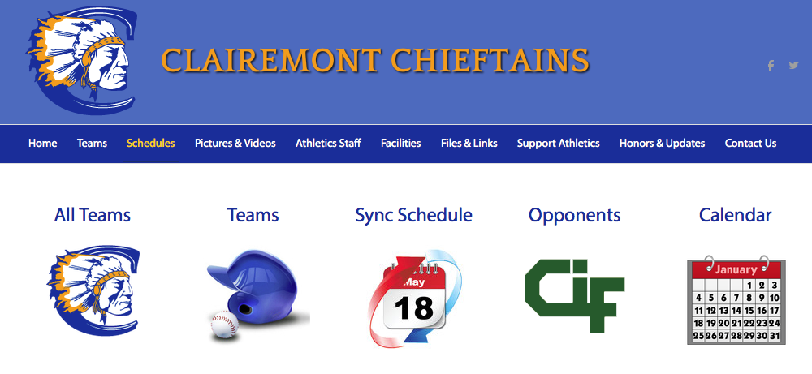

 | Single  Free | Double  $175/Year | Triple  $350/Year | Home Run  $495/ Year | Grand Slam  $995/Year
Users | ✓ | ✓ | ✓ | ✓ | ✓
Games | ✓ | ✓ | ✓ | ✓ | ✓
Practices | ✓ | ✓ | ✓ | ✓ | ✓
Team Events | ✓ | ✓ | ✓ | ✓ | ✓
School Events | ✓ | ✓ | ✓ | ✓ | ✓
Non-School Events | ✓ | ✓ | ✓ | ✓ | ✓
Students | ✓ | ✓ | ✓ | ✓ | ✓
Coaches | ✓ | ✓ | ✓ | ✓ | ✓
Athletic Facility | ✓ | ✓ | ✓ | ✓ | ✓
Schedule Importing |  | ✓ | ✓ | ✓ | ✓
Score Poster |  | ✓ | ✓ | ✓ | ✓
Multiple Game Template |  | ✓ | ✓ | ✓ | ✓
Facilities |  |  | ✓ | ✓ | ✓
Reports |  |  | ✓ | ✓ | ✓
Widgets |  |  |  | ✓ | ✓
Custom Website |  |  |  |  | ✓

